# Distributed Data Platform on Microsoft Azure Virtual Machines

The framework will automate many of the steps for creating a distributed data cluster on Windows Azure Virtual Machines.

The framework will automate the generation of the Azure based infrastructure, and walk through the manual steps to configure the environment. The framework is a blend of PowerShell based automation coupled with manual configuration.

The following instructions were tested on Ubuntu 12.04.3 LTS, Oracle Linux 6 and CentOS 6.3/6.5.

# Overview

This document will walk you through the below steps to create your cluster via a combination of scripted commands and manual steps. You do not need to pre-create any Azure services. The detailed steps for each item are described further down in the document.

1. Plan the size, configuration, and naming standards for the cluster.
2. Update ClusterConfig.xml with cluster settings.
3. Most clusters or farms have one node that is used to manage the other nodes, we will refer to that as the “management node” throughout this document. Create the Management Node: Execute 1_Management_Node.ps1
   1. Create the Affinity Group (if it doesn’t exist)
   2. Validate the Virtual Network exists
   3. Create the Storage Accounts (if they don’t exist)
   4. Create the Management virtual machine
4. Create the Clone VM that will be used as a base VM for all the other nodes in the cluster: Execute 2_Clone_Node.ps1
5. Manually configure the Management and Clone nodes
   1. Set root passwords
   2. Set up passwordless SSH between the Management Node and the Clone Node
   3. Set various server configurations to meet software installation requirements
   4. Add disk mount script
6. Deprovision the Clone Node to enable it for use as an image.
   1. Update waagent.conf
   2. Run waagent –deprovision
7. Create the Windows Azure Clone Image: Execute 3_Capture_Image.ps1
   1. Stop the Clone Node
   2. Capture an image
8. Create the cluster nodes: Execute 4_Cluster_Nodes
   1. Creates multiple Windows Azure Virtual Machines using the Clone image
9. Restart the Management node.
10. Update hosts and mount drives on each node
11. Install management and installation software on Management Node
12. Install software on cluster

# Dependencies

* Windows Azure PowerShell: <http://www.windowsazure.com/en-us/documentation/articles/install-configure-powershell/> Follow instructions to import publish file for PowerShell. Restart PowerShell after installing cmdlets.
* Windows Azure Command Line Interface: <http://azure.microsoft.com/en-us/documentation/articles/xplat-cli/> Follow instructions to import publish file for Azure CLI. Restart PowerShell after installing the CLI.
* PuTTY or another SSH tool: <http://www.putty.org>
* WinSCP or another tool to transfer files to the Linux image: <http://winscp.net/eng/index.php>
* Windows Azure Subscription with adequate available VM cores, cloud services and storage accounts. You can request an increase in your billing quota by clicking on the support link and creating a billing ticket. {link} {http://msdn.microsoft.com/en-us/library/azure/dn689095.aspx}
* A Windows machine (use CLI/BASH version if creating the Azure environment from Mac or Linux)

# Planning

Determine the cluster requirements before executing the scripts:

1. How many nodes in the cluster
2. Virtual machine size
3. Number of cloud services
4. Number of storage accounts
5. Naming conventions for cloud services, storage accounts and virtual machines
6. Virtual network configuration

If needed, update the subscription quotas to support the cluster configuration virtual machine cores, storage accounts, cloud services, etc: <http://azure.microsoft.com/en-us/support/options/>

# Preparation

## Microsoft Azure PowerShell

Download and install Microsoft Azure PowerShell: <http://www.windowsazure.com/en-us/downloads/>.

Follow online instructions for setting up the subscription with Windows Azure PowerShell: <http://www.windowsazure.com/en-us/documentation/articles/install-configure-powershell/>.

The PowerShell ISE (Integrated Scripting Environment) is often easier to use when developing and testing script execution. Type ISE in the traditional Windows Azure PowerShell interface to open the PowerShell ISE.

## Configure Windows Azure PowerShell and Command Line Environment

Set PowerShell defaults for the new storage account. In the PowerShell ISE execute the following command.

**Set-AzureSubscription –SubscriptionName $subscriptionName   
–CurrentStorageAccount $clusterStorageAccount**

Some commands in the PowerShell scripts will execute via the Azure Cross-Platform Command Line. Download and install the Azure Cross-Platform Command Line interface. Follow online instructions for setting up the subscription with Azure Command Line. <http://azure.microsoft.com/en-us/documentation/articles/xplat-cli/>

## PuTTY

Download and install PuTTY or another SSH tool: <http://www.putty.org>

## WinSCP

Download and install WinSCP: <http://winscp.net/eng/index.php>

## Create the Virtual Network in Microsoft Azure

Create the virtual network in Microsoft Azure. Network can be created in the Microsoft Azure Portal (<https://manage.windowsazure.com/>). Use the custom create method in the portal to create the virtual network with the subnet.

# Distributed Data Platform on Microsoft Azure Virtual Machines

## Update ClusterConfig.xml

All settings to drive the deployment of the cluster are stored in ClusterConfig.xml. A sample ClusterConfig Sample.xml has been included in the project for reference.

Open ClusterConfig.xml to edit. Notepad and Visual Studio are options for editing xml documents.

Begin with the cluster level settings. Input the subscription where the cluster will be deployed. This is the subscription that was set up in the previous section when configuring PowerShell.

<SubscriptionName>MySubscription</SubscriptionName>

### Affinity Group

An example of affinity group settings are as follows. Note that the affinityGroupName must be globally unique.

<!--Affinity Group Settings-->

<!--affinityGroupLocation is the location where the cluster will deploy. East US, West US, East Asia, Southeast Asia, North Europe, West Europe are examples of valid locations-->

<!--affinityGroupName must be globally unique-->

<affinityGroupLocation>West US</affinityGroupLocation>

<affinityGroupName>ddpWest</affinityGroupName>

<affinityGroupDescription>Affinity Group DDP Sample</affinityGroupDescription>

<affinityGroupLabel>AG for DDP Sample</affinityGroupLabel>

### Virtual Network

An example of virtual network settings are as follows. The virtual network must already exist. Input the existing settings in the configuration file.

<!--Virtual Network Settings-->

<!--Valid address space settings include 192.168.0.0, 10.0.0.0 and 172.16.0.0 -->

<virtualNetworkName>ddp01</virtualNetworkName>

<virtualNetworkAddressSpace>172.16.0.0</virtualNetworkAddressSpace>

<virtualNetworkCIDR>17</virtualNetworkCIDR>

<virtualSubnetname>App</virtualSubnetname>

<subnetAddressSpace>172.16.0.0</subnetAddressSpace>

<subnetCIDR>17</subnetCIDR>

### Storage Accounts

The storageAccountName is the primary storage account used for the data disks and OS disks of the Management node, and the OS disks of the cluster nodes. The storage accounts listed under storageAccountList are used to store the data disks for the cluster nodes. Add or remove <Name> nodes in the XML document to add or remove additional storage accounts.

All storage account names must be lower case and globally unique.

This example will create a total of three storage accounts: The primary storage account named ddp0 and two additional storage accounts ddp1 and ddp2.

<!--Storage Account Settings-->

<!--All storage account names must be globally unique-->

<storageAccountName>ddp0</storageAccountName>

<storageAccountList>

<Name>ddp1</Name>

<Name>ddp2</Name>

</storageAccountList>

### Virtual Machines

The virtual machine settings will drive the configuration of the Management node, Clone node and some aspects of the Cluster nodes. All virtual machines in the cluster will have the same adminUserName and adminPassword.

The vmNamePrefix will drive the name of the Management node (vmNamePrefix + 0) and the Clone node (vmNamePrefix + c). Different naming conventions may be used for the cluster nodes based on settings later in the ClusterConfig.xml.

The cloudServicePrefix will drive the name of the cloud service for both the Management node and the Clone node. The cloudServicePrefix must be globally unique.

<!--Virtual Machine Settings-->

<adminUserName>clusteradmin</adminUserName>

<adminPassword>Password.1</adminPassword>

<vmNamePrefix>ddp</vmNamePrefix>

<cloudServicePrefix>ddp</cloudServicePrefix>

### Host Files

Two files are generated during the execution of the process: hosts.txt and hostscript.sh. The hosts.txt is updated with the host name and IP address of the Management node and all cluster nodes. The hostscript.sh file writes commands that will update all hosts in the cluster and create the filesystem on each virtual machine. By default, these files are generated in the same location as the scripts.

<!--do not change the hosts/hostscript names-->

<hostsfile>.\hosts.txt</hostsfile>

<hostscript>.\hostscript.sh</hostscript>

### Management Node and Clone Node

All Management node and Clone node specific settings are in the ManagementNode and CloneNode sections. Cluster management software is installed on the Management node (sometimes referred to as an Operations node or Edge node by OSS partners).

The Clone node is the master image that will be used to stamp out virtual machines later in the process.

The Management node and Clone node are created based on a gallery image. The gallery image selection will return the latest image that meets a LIKE search of the Image labels in the Azure virtual machine gallery. If a specific image and version is preferred, update the appropriate section in the 1_Management_Node.ps and 2_Clone_Node.ps scripts with an equality statement.

Valid instanceSize settings are available online: <http://msdn.microsoft.com/en-us/library/azure/dn197896.aspx>. Most distributed data platform software will require a minimum virtual machine size of ExtraLarge.

Specify the number of disks and size of disks to attach to the Management node. Disks are not attached to the Clone node, as they are attached later in the process after the cluster nodes are generated.

<!--Set Management Node Variables-->

<ManagementNode>

<galleryimageName>OpenLogic</galleryimageName>

<instanceSize>A7</instanceSize>

<diskSizeInGB>500</diskSizeInGB>

<numOfDisks>2</numOfDisks>

<installerPort>8080</installerPort>

</ManagementNode>

<!--Set Clone Node Variable-->

<CloneNode>

<galleryimageName>OpenLogic</galleryimageName>

<instanceSize>A7</instanceSize>

</CloneNode>

### Clone Image

After the Management node and the Clone node have been updated with the proper settings to optimize for the distributed data platform software, the Clone node is stopped and captured as an image. The name of the image is based on the value cloneimageName, and cloneimageLabel is a descriptive label for the image.

<!--Set Clone Image Variables-->

<!--Set the name and label of the Clone Image. -->

<CloneImage>

<cloneimageName>ddpc</cloneimageName>

<cloneimageLabel>DDP Clone</cloneimageLabel>

</CloneImage>

### Cluster Nodes

The cluster nodes are generated from the Clone image.

Valid instanceSize settings are available online: <http://msdn.microsoft.com/en-us/library/azure/dn197896.aspx>. Most distributed data platform software will require a minimum virtual machine size of ExtraLarge.

Specify the number of disks and size of disks to attach to the Cluster nodes. The filesystem will be configured after the Cluster nodes are created.

All cluster nodes are created with a naming convention based on the vmNamePrefix followed by a number between 1 and the value in numNodes. All cluster nodes will be created in cloud services that are named based on a naming convention based on cloudServicePrefix followed by a number between 1 and the value in numCloudServices.

Total nodes is the total number of virtual machines to create for all roles in the cluster. How these nodes are used in the cluster will be determined when the OSS software is installed. For example, decisions on which virtual machines will serve as the name nodes in Hadoop are made when installing Hadoop. In this example, the numNodes value should include the name node(s) + data nodes needed for the cluster.

<!--Set Cluster Nodes Variables-->

<ClusterNodes>

<instanceSize>A7</instanceSize>

<diskSizeInGB>1000</diskSizeInGB>

<numOfDisks>4</numOfDisks>

<vmNamePrefix>ddp</vmNamePrefix>

<cloudServicePrefix>ddp</cloudServicePrefix>

<numNodes>10</numNodes>

<numCloudServices>2</numCloudServices>

</ClusterNodes>

## Create Management and Clone Node

Open PowerShell and execute the following block to create the Management Node. Update the file paths to the location where the scripts are located. This script is also available in the “Execute Scripts V3.ps1” included in the framework. The 1_Management_Node.ps1 script is described in detail in Appendix A.

#################################################################################

## Management Node

#################################################################################

cd "<Insert file path to scripts>"

[xml]$ddpconfig = Get-Content "<Name of the config.xml file>"

Select-AzureSubscription -SubscriptionName $ddpconfig.Cluster.SubscriptionName

.\1_Management_Node.ps1 -imageName $ddpconfig.Cluster.ManagementNode.galleryimageName `

-adminUserName $ddpconfig.Cluster.adminUserName `

-adminPassword $ddpconfig.Cluster.adminPassword`

-instanceSize $ddpconfig.Cluster.ManagementNode.instanceSize`

-diskSizeInGB $ddpconfig.Cluster.ManagementNode.diskSizeInGB `

-numOfDisks $ddpconfig.Cluster.ManagementNode.numOfDisks `

-vmNamePrefix $ddpconfig.Cluster.vmNamePrefix `

-cloudServiceName $ddpconfig.Cluster.cloudServicePrefix `

-storageAccountName $ddpconfig.Cluster.storageAccountName `

-storageAccountList $ddpconfig.Cluster.storageAccountList.Name `

-affinityGroupLocation $ddpconfig.Cluster.affinityGroupLocation `

-affinityGroupName $ddpconfig.Cluster.affinityGroupName `

-affinityGroupDescription $ddpconfig.Cluster.affinityGroupDescription `

-affinityGroupLabel $ddpconfig.Cluster.affinityGroupLabel `

-virtualNetworkName $ddpconfig.Cluster.virtualNetworkName `

-virtualNetworkAddressSpace $ddpconfig.Cluster.virtualNetworkAddressSpace `

-virtualNetworkCIDR $ddpconfig.Cluster.VirtualNetworkCIDR `

-virtualSubnetname $ddpconfig.Cluster.virtualSubnetname `

-subnetAddressSpace $ddpconfig.Cluster.SubnetAddressSpace `

-subnetCIDR $ddpconfig.Cluster.SubnetCIDR `

-installerPort 7180 `

-hostscript $ddpconfig.Cluster.hostscript `

-hostsfile $ddpconfig.Cluster.hostsfile `

-subscriptionName $ddpconfig.Cluster.SubscriptionName

Open PowerShell and execute the following block to create the Clone Node. Update the file paths to the location where the scripts are located. This script is also available in the “Execute Scripts V3.ps1” included in the framework. The 2_Clone_Node.ps1 script is described in detail in Appendix A.

#################################################################################

## Clone Node

## Create the clone node used for generating the data nodes and name nodes.

#################################################################################

cd "<Insert file path to scripts>"

[xml]$ddpconfig = Get-Content "<Name of the config.xml file>"

Select-AzureSubscription -SubscriptionName $ddpconfig.Cluster.SubscriptionName

.\2_Clone_Node.ps1 -imageName $ddpconfig.Cluster.CloneNode.galleryimageName `

-adminUserName $ddpconfig.Cluster.adminUserName `

-adminPassword $ddpconfig.Cluster.adminPassword `

-instanceSize $ddpconfig.Cluster.CloneNode.instanceSize `

-diskSizeInGB 0 `

-numOfDisks 0 `

-vmNamePrefix $ddpconfig.Cluster.vmNamePrefix `

-cloudServiceName $ddpconfig.Cluster.cloudServicePrefix `

-storageAccountName $ddpconfig.Cluster.storageAccountName `

-affinityGroupName $ddpconfig.Cluster.affinityGroupName `

-virtualNetworkName $ddpconfig.Cluster.virtualNetworkName `

-virtualSubnetname $ddpconfig.Cluster.virtualSubnetname `

-subscriptionName $ddpconfig.Cluster.SubscriptionName

## Manually Configure the Management and Clone Nodes

Verify the two virtual machines have completed provisioning and are running.

The Management Node is named the value supplied in the ClusterConfig.xml setting vmNamePrefix followed by 0, and the Clone Node is named the value supplied in the setting vmNamePrefix followed by “c”. Use PuTTY or another SSH tool to configure these nodes.

In addition to the DNS name, you may need the SSH public endpoint, private IPs, and public IPs of the Management Node and the Clone Node to proceed with this section. The virtual machine IP addresses can be found by viewing the properties of the virtual machine in the [Microsoft Azure Management Portal](https://manage.windowsazure.com/). The SSH endpoint is available by select ENDPOINTS in the upper menu of the virtual machine.

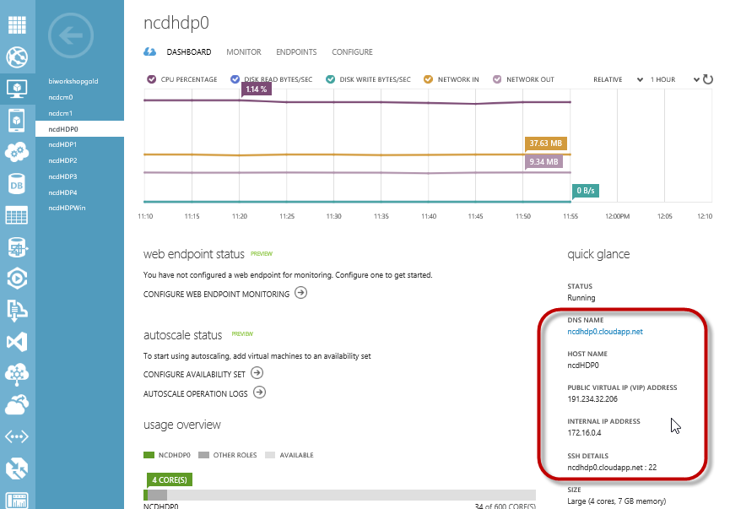

Open PuTTY and input the public SSH port with the Management Node public IP address or the DNS name with the public SSH port. Click Open.

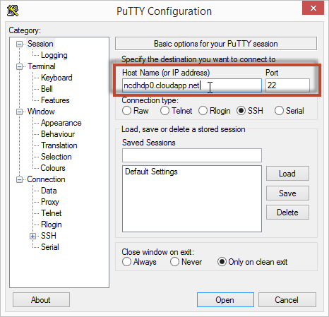

You will be prompted for a login and password. Enter the value used in the ClusterConfig.xml setting adminUserName with the password you provided in the setting adminPassword.

### Set root passwords

Set the root passwords on both the Management Node and Clone Node. You are currently connected to the Management node. You can tell which node you are connected to by the prompt – it is in the format user@node_name.

Elevate to root. Enter the password for the adminUserName when prompted. Update the root password with the command **passwd**. Enter the new password when prompted.

**sudo -s**

**passwd**

SSH to the Clone Node. Enter the password (adminPassword) for the adminUserName when prompted.

**ssh <adminUserName>@<Cloud Service Name>.cloudapp.net –p <Clone SSH port>**

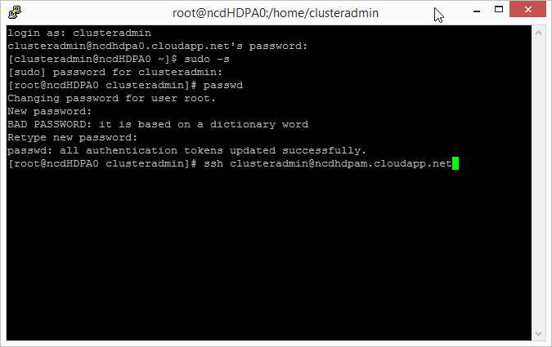

Elevate to root. Enter the password for the adminUserName when prompted.

Update the root password with the **passwd** command. Enter the new password when prompted.

**sudo -s**

**passwd**

With both root passwords set, the next step will configure the nodes for the cluster.

### Set up passwordless SSH between the Management Node and the Clone Node

In the Management node generate the key. This must be done under the context of root.

**ssh <Cloud Service Name>.cloudapp.net -p <Management SSH port>**

**ssh-keygen**

Accept the default file location when prompted (press enter). Press enter (twice) to create the key without a passphrase. The public key is stored in .ssh/id_rsa.pub, and the private key is id_rsa.

Copy the key to the Clone node and Management node (self-referencing), enter the root password when prompted. The following example connects to the nodes with DNS. The screenshot demonstrates connecting to the node with the private IP.

**ssh-copy-id -i /root/.ssh/id_rsa.pub "root@<Cloud Service Name>.cloudapp.net -p <Clone SSH Port>"**

**ssh-copy-id -i /root/.ssh/id_rsa.pub "root@<Cloud Service Name>.cloudapp.net -p <Management SSH Port>"**

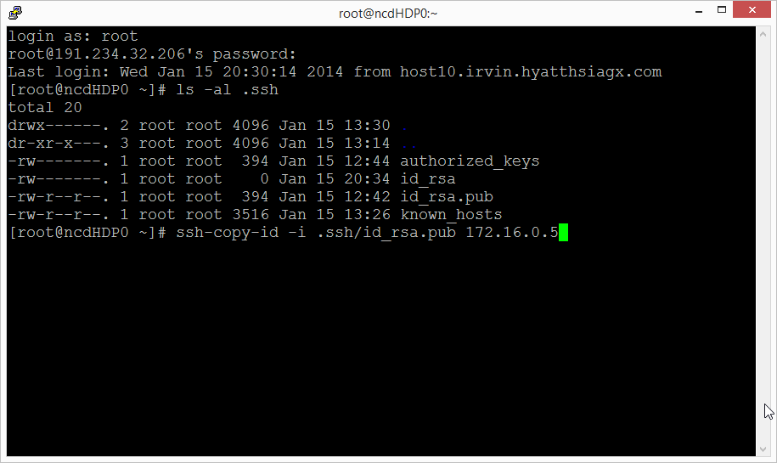

To test the keys were set up correctly, type the following and validate that you are not prompted for a password.

**ssh <Cloud Service Name>.cloudapp.net -p <Management SSH Port>**

**ssh <Cloud Service Name>.cloudapp.net -p <Clone SSH Port>**

Note that the passwordless ssh is not reciprocal. You will be prompted for a password when you are returning to the Management Node from the Clone Node.

Return to the Management node to configure the final settings.

**ssh <Cloud Service Name.cloudapp.net -p <Management SSH Port>**

### Add Script to Mount Disks

The script makefilesystem.sh shell script will create partitions and filesystems for the cluster nodes. This script will be executed later in the process. This step will load the script to the virtual machines.

1. Open WinSCP and connect to the Management node **as root**. Drag and drop the makefilesystem.sh script from the framework source files to the Management node root folder.
   1. ***If the files are not dropped in the root, subsequent steps will not work.***
2. Connect to the Clone node **as root** and repeat moving the makefilesystem.sh file to the Clone node root folder.

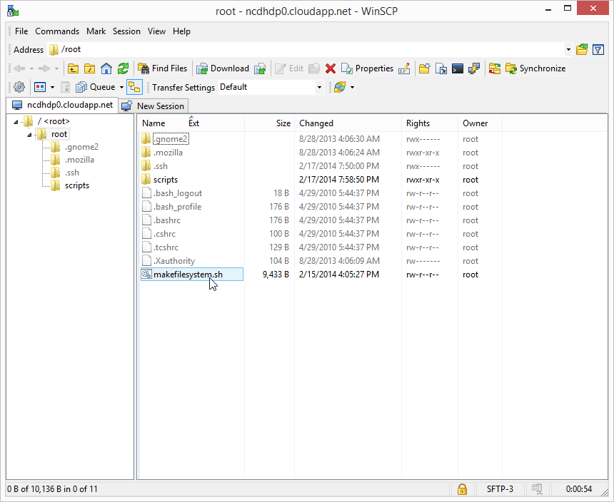

### Update Server Configuration Settings

Using PuTTY connect to the Management node and Clone node to configure the nodes. Execute the following to move and secure the makefilesystem.sh script, and install and use dos2unix to convert makefilesystem.sh file to a Linux friendly format. The final steps will configure prerequisite server settings.

1. Connect to the Management node **as root**. Execute the following commands on the management node. Choose the block based on the node’s Linux version.

**CentOS, Oracle**

**cd ~**

**mkdir /root/scripts**

**mv makefilesystem.sh /root/scripts/makefilesystem.sh**

**chmod 755 /root/scripts/makefilesystem.sh**

**yum -y install dos2unix**

**dos2unix /root/scripts/makefilesystem.sh /root/scripts/makefilesystem.sh**

**#disable iptables**

**chkconfig iptables off**

**/etc/init.d/iptables stop**

**setenforce 0**

**#start ntp service**

**yum -y install ntp**

**chkconfig ntpd on**

**ntpdate pool.ntp.org**

**sudo echo 'vm.swappiness = 0' >> /etc/sysctl.conf**

**sed -i 's/SELINUX=enforcing/SELINUX=disabled/g' /etc/selinux/config**

**echo never > /sys/kernel/mm/transparent_hugepage/enabled**

**echo never > /sys/kernel/mm/redhat_transparent_hugepage/defrag**

**echo "echo never > /sys/kernel/mm/transparent_hugepage/enabled">>/etc/rc.local**

**echo "echo never > /sys/kernel/mm/redhat_transparent_hugepage/defrag">>/etc/rc.local**

**Ubuntu**

**cd ~**

**mkdir /root/scripts**

**mv makefilesystem.sh /root/scripts/makefilesystem.sh**

**chmod 755 /root/scripts/makefilesystem.sh**

**apt-get -y install dos2unix**

**dos2unix /root/scripts/makefilesystem.sh /root/scripts/makefilesystem.sh**

**#disable firewall**

**ufw disable**

**#start ntp service**

**apt-get -y install ntp**

**chkconfig ntpd on**

**ntpdate pool.ntp.org**

**echo 'vm.swappiness = 0' >> /etc/sysctl.conf**

**sed -i 's/SELINUX=enforcing/SELINUX=disabled/g' /etc/selinux/config**

**echo never > /sys/kernel/mm/transparent_hugepage/enabled**

**echo never > /sys/kernel/mm/redhat_transparent_hugepage/defrag**

**echo "echo never > /sys/kernel/mm/transparent_hugepage/enabled">>/etc/rc.local**

**echo "echo never > /sys/kernel/mm/redhat_transparent_hugepage/defrag">>/etc/rc.local**

1. SSH to the Clone node **as root** and repeat the previous step.
2. Restart the Management node to disable SELINUX, which is required for software installation (ie Ambari and Cloudera Manager).

Verify that the directory scripts exists in root and makefilesystem.sh is the only file in the directory.

Review the output from the scripts to verify all steps succeeded.

### Deprovision Clone Node With Windows Azure Linux Agent

Connect to the Clone node **as root** using PuTTY. **This will not be run on the Management Node!** Set up the virtual machine for provisioning as an image. Open the waagent.conf file.

**vi /etc/waagent.conf**

If you are new to vi, type i to enter insert mode. Navigate to the correct line in the file and update. Press Esc to exit insert mode, type :wq to save changes and return to the command prompt.

Change the following settings by typing i to enter insert mode:

**Provisioning.DeleteRootPassword=n**

**Provisioning.RegenerateSshHostKeyPair=n**

Press esc to exit insert mode. Type :wq and press enter to save and close the file.

Run the Windows Azure Linux Agent.

**waagent -deprovision**

Return to the Management node as root, entering the password when prompted.

**ssh <Cloud Service Name>.cloudapp.net –p <Management SSH Port>**

## Capture the Image

Open PowerShell and execute the following block to stop the Clone node virtual machine and capture the Clone image. Update the file paths to the location where the scripts are located. This script is also available in the “Execute Scripts V3.ps1” included in the framework. The 3_Capture_Image.ps1 script is described in detail in Appendix A.

#################################################################################

## Capture the image

#################################################################################

cd "<Insert file path to scripts>"

[xml]$ddpconfig = Get-Content "<Name of the config.xml file>"

Select-AzureSubscription -SubscriptionName $ddpconfig.Cluster.SubscriptionName

.\3_Capture_Image.ps1 -cloudServiceName $ddpconfig.Cluster.cloudServicePrefix `

-vmName $vmNamePrefix `

-imageName $ddpconfig.Cluster.CloneImage.cloneimageName `

-imageLabel $ddpconfig.Cluster.CloneImage.cloneimageLabel `

-subscriptionName $ddpconfig.Cluster.SubscriptionName

## Create Cluster Nodes

Open PowerShell and execute the following create the cluster node virtual machines. Update the file paths to the location where the scripts are located. This script is also available in the “Execute Scripts V3.ps1” included in the framework. The 4_Cluster_Nodes.ps1 is described in detail in Appendix A.

#################################################################################

## Create the worker nodes

#################################################################################

cd "<Insert file path to scripts>"

[xml]$ddpconfig = Get-Content "<Name of the config.xml file>"

Select-AzureSubscription -SubscriptionName $ddpconfig.Cluster.SubscriptionName

.\4_Cluster_Nodes.ps1 -imageName $ddpconfig.Cluster.CloneImage.cloneimageName `

-adminUserName $ddpconfig.Cluster.adminUserName `

-adminPassword $ddpconfig.Cluster.adminPassword `

-instanceSize $ddpconfig.Cluster.ClusterNodes.instanceSize `

-diskSizeInGB $ddpconfig.Cluster.ClusterNodes.diskSizeInGB `

-numOfDisks $ddpconfig.Cluster.ClusterNodes.numOfDisks `

-vmNamePrefix $ddpconfig.Cluster.ClusterNodes.vmNamePrefix `

-cloudServicePrefix $ddpconfig.Cluster.ClusterNodes.cloudServicePrefix `

-numCloudServices $ddpconfig.Cluster.ClusterNodes.numCloudServices `

-numNodes $ddpconfig.Cluster.ClusterNodes.numNodes `

-affinityGroupName $ddpconfig.Cluster.affinityGroupName `

-virtualNetworkName $ddpconfig.Cluster.virtualNetworkName `

-virtualSubnetname $ddpconfig.Cluster.virtualSubnetname `

-storageAccountName $ddpconfig.Cluster.storageAccountName `

-storageAccountList $ddpconfig.Cluster.storageAccountList.Name `

-hostsfile $ddpconfig.Cluster.hostsfile `

-hostscript $ddpconfig.Cluster.hostscript `

-subscriptionName $ddpconfig.Cluster.SubscriptionName

## Update Cluster Machines

Use WinSCP to copy the following files to root directory of the Management node: hosts.txt, hostscript.sh, updatehosts.sh.

The $hostsfile and $hostscript files are generated during the previous step and are not complete until the 4_Cluster_Nodes.ps1 script has finished.

Your hosts.txt and hostscript.sh may have different names depending on your input for the $hostsfile and $hostscript settings in the ClusterConfig.xml. Typically you will not change the location of the $hostsfile and $hostscript.

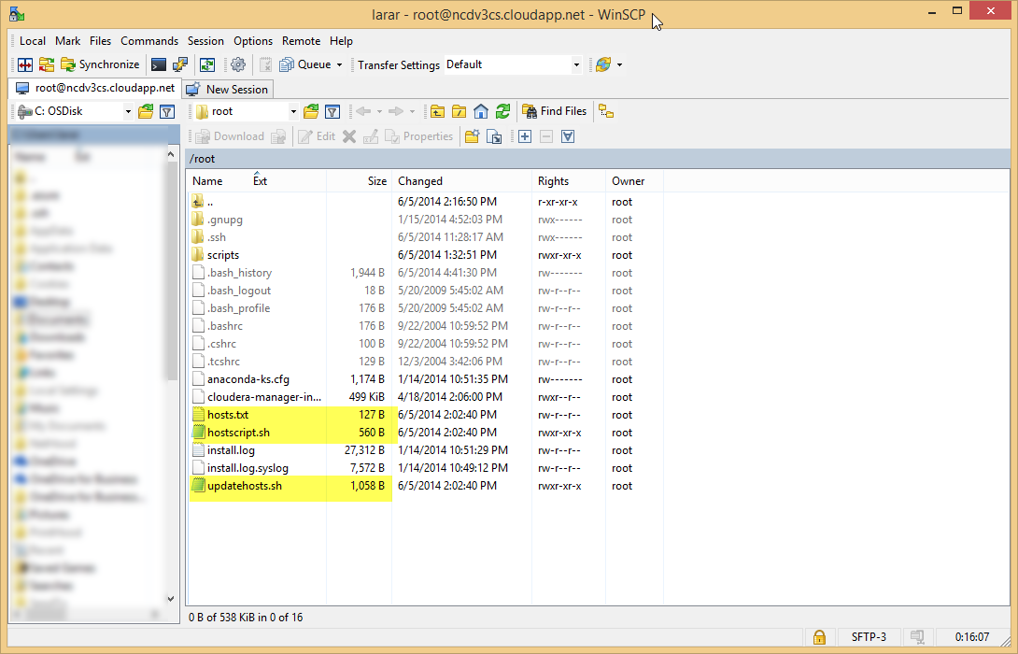

After the files are loaded in the Management node, return to PuTTY with a connection to the Management node **as root**. Run the following commands to convert the files using dos2unix and secure the files. Update the statements if the hosts.txt and/or hostscript.sh have different names in your deployment.

**dos2unix hosts.txt hosts.txt**

**dos2unix hostscript.sh hostscript.sh**

**dos2unix updatehosts.sh updatehosts.sh**

**chmod 755 updatehosts.sh**

**chmod 755 hostscript.sh**

Using PuTTY with a connection to the Management node as root, execute updatehosts.sh to update /etc/hosts with the information from the hosts.txt file. Execute hostscript.sh to mount the drives on all machines in the cluster. Update the ./hostscript.sh statement if the file has a different name in your deployment.

**./updatehosts.sh**

**./hostscript.sh**

At the completion of the script a set of virtual machines is ready for the software installation.

To test that the virtual machines were generated correctly, open a PuTTY connection from the Management node and connect to a few of the machines to verify the host name and to verify passwordless ssh is working:

**ssh <hostname>**

# Appendix A: Scripts

## 1_Management_Node.ps1

This script will execute multiple steps.

1. Executes 0_Create_AG_Storage_VNet.ps1, which creates an affinity group and the storage accounts. It will check that the virtual network exists as specified in the configuration file.
2. Creates a virtual machine which will act as the management node (some vendors may refer to this as the edge node). The virtual machine is named as the value passed into the $vmNamePrefix followed by 0. This image is where the distribution management software is installed (i.e. Hortonworks Ambari or Cloudera’s Cloudera Manager).
3. Write private IP and machine name to the file specified in the $hostsfile parameter. This file will be used later in the process to update the hosts file on each of the cluster nodes.
4. Write to the file specified in the $hostsscript parameter. This file will be used later in the process to execute commands to update the hosts files and mount the disks on the cluster nodes.
5. Set static IP on the management node virtual machine.

The script requires the following parameters representing the environment settings.

|  |  |
| --- | --- |
| Parameter name | Purpose |
| $imageName | The name of the Windows Azure image which will be used for provisioning the virtual machines. |
| $adminPassword | The password that will be generated in the virtual machines for the administrator of the virtual machines. |
| $adminUserName | The user name of the administrator account that will be created on the virtual machines. |
| $instanceSize | The size of the Windows Azure Virtual Machines (ie Small, Medium, Large, ExtraLarge, etc). Virtual machine sizes are detailed online: <http://msdn.microsoft.com/en-us/library/windowsazure/dn197896.aspx>. Large or ExtraLarge are recommended for many distributed data platforms, and A7s are recommended by vendors as the minimum size for many products. |
| $diskSizeInGB | The size of the disk to attach to the Management node. |
| $numofDisks | The number of disks to attach to the Management node. |
| $vmNamePrefix | Naming convention for the virtual machines. All virtual machines will be named based on this prefix. |
| $cloudServiceName | Name for the cloud service used for the Management node and Clone node. In general, this will be the same as the $vmNamePrefix for ease of management.  Additional cloud services will be created in a later step. It is recommended to choose a consistent naming convention for this cloud service and the subsequent cloudServicePrefix in the later step. |
| $storageAccountName | Name of the primary storage account that will store the OS and data disks for the Management Node and Clone node/image. This will also store the OS disks for the data nodes.  If the storage account doesn’t exist, the script will create the account. It is recommended to use an empty storage account. |
| $storageAccountList | Array of storage account names that will store the data disks for the data nodes.  If the storage accounts do not exist, the script will create the accounts. It is recommended that these are not used for other purposes and are dedicated for the cluster. |
| $affinityGroupLocation | The Windows Azure data center where the virtual machines will be deployed. Choose a data center that is the same location as the storage account with the data to analyze.  Execute Get-AzureLocation from PowerShell or “azure vm location list” from the Azure Command Line to the the complete list of locations. |
| $affinityGroupName | The name of the affinity group (must be unique in your subscription). |
| $affinityGroupDescription | The description for the affinity group. |
| $affinityGroupLabel | The label for the affinity group. |
| $virtualNetworkName | The name for the virtual network (must be unique in your subscription). |
| $virtualNetworkAddressSpace | The virtual network address space. Valid address spaces are 192.168.0.0, 10.0.0.0 and 172.16.0.0. |
| $virtualNetworkCIDR | The virtual network CIDR. |
| $virtualSubnetName | The name of the virtual subnet. |
| $subnetAddressSpace | The subnet address space. Valid address spaces are 192.168.0.0, 10.0.0.0 and 172.16.0.0. |
| $subnetCIDR | The subnet CIDR. |
| $installerPort | Port number for the distribution installer. On Hortonworks the default is 8080 and on Cloudera the default 7180. |
| $hostsfile | The location of the hosts file that is generated during the cluster creation. This is optional, with a default of “.\hosts.txt” |
| $hostscript | The location of the shell script to update the cluster nodes that is generated during the cluster creation. This is optional, with a default of “.\hostscript.sh” |
| $subscriptionName | The name of the subscription where the cluster will be created. |

## 2_Clone_Node.ps1

This script creates a virtual machine which will act as a clone. The clone will be the master copy virtual machine, which will be the basis of all virtual machines in the cluster.

The script requires the following parameters representing the environment settings.

|  |  |
| --- | --- |
| Parameter name | Purpose |
| $imageName | The name of the Windows Azure image which will be used for provisioning the virtual machines. |
| $adminUserName | The user name of the administrator account that will be created on the virtual machines. |
| $adminPassword | The password that will be generated in the virtual machines for the administrator of the virtual machines. |
| $instanceSize | The size of the Windows Azure Virtual Machines (ie Small, Medium, Large, ExtraLarge, etc). Virtual machine sizes are detailed online: <http://msdn.microsoft.com/en-us/library/windowsazure/dn197896.aspx>. Medium or larger is recommended. Since this node does not persist, the size only needs to be large enough for optimal performance during the manual configuration steps. |
| $diskSizeInGB | The size of the disk to attach to the virtual machines, default value of 0. The clone node should not attach disks. These will be attached to the cluster nodes in a later step. |
| $numofDisks | The number of disks to attach to the virtual machines, default value of 0. The clone node should not attach disks. These will be attached to the cluster nodes in a later step. |
| $vmNamePrefix | Naming convention for the virtual machines. The clone is named $vmNamePrefix followed by “c”. |
| $cloudServiceName | Name of the cloud service. This will be the same cloud service that was used in the previous step to create the management node. |
| $storageAccountName | Name of the primary storage account where the clone OS is stored. This will be the same storage account that was used in the previous step to create the management node. |
| $affinityGroupName | The name of the affinity group (must be unique in your subscription). |
| $virtualNetworkName | The name for the virtual network (must be unique in your subscription). |
| $virtualSubnetName | The name of the virtual subnet. |
| $subscriptionName | The name of the subscription where the cluster will be created. |

## 3_Capture_Image.ps1

The image will be used to generate all of the nodes in the cluster.

Execute the script with the parameters representing the appropriate parameters.

|  |  |
| --- | --- |
| Parameter name | Purpose |
| $cloudServiceName | The cloud service name for the clone virtual machine that will be converted to an image. |
| $vmName | The virtual machine name for the clone virtual machine that will be converted to an image. |
| $imageName | The name of the image that will be created. |
| $imageLabel | A short description label for the image that will be created. |
| $subscriptionName | The name of the subscription where the cluster will be created. |

## 4_Cluster_Nodes.ps1

Execute the script with the parameters representing the appropriate environment settings.

|  |  |
| --- | --- |
| Parameter name | Purpose |
| $imageName | The name of the Clone image which will be used for provisioning the virtual machines. |
| $adminUserName | The user name of the administrator account. |
| $adminPassword | The password that will be generated in the virtual machines for the administrator. |
| $instanceSize | The size of the Windows Azure Virtual Machines (ie Small, Medium, Large, ExtraLarge, etc). Virtual machine sizes are detailed online: <http://msdn.microsoft.com/en-us/library/windowsazure/dn197896.aspx>. Most OSS data platform will require/recommend a minimum of ExtraLarge, depending on the size of your cluster and the services you plan to employ. |
| $diskSizeInGB | The size of the disk to attach to the virtual machines. |
| $numofDisks | The number of disks to attach to the virtual machines |
| $vmNamePrefix | Naming convention for the virtual machines. All virtual machines will be named based on this prefix followed by an incrementing number. |
| $cloudServicePrefix | Naming convention for the cloud services. In general, this will be the same as the $vmNamePrefix for ease of management. |
| $numCloudServices | The total number of cloud services to create for the cluster. VMs are distributed evenly in the cloud services. |
| $numNodes | The total number of virtual machines to create for the cluster. |
| $affinityGroupName | The name of the affinity group for the cluster. |
| $virtualNetworkName | The name for the virtual network (must be unique in your subscription). |
| $virtualSubnetName | The name of the virtual subnet. |
| $storageAccountName | The name of the storage account to use for the cluster node OS VHD storage. |
| $storageAccountList | Array of storage account names that will store the data disks for the data nodes.  If the storage accounts do not exist, the script will create the accounts. It is recommended that these are not used for other purposes and are dedicated for the cluster. |
| $hostsfile | The location of the hosts file that is generated during the cluster creation. This is optional, with a default of “.\hosts.txt” |
| $hostscript | The location of the cluster update shell script file that is generated during the cluster creation. This is optional, with a default of “.\hostscript.sh” |
| $subscriptionName | The name of the subscription where the cluster will be created. |

# Appendix B: Install Ambari

Open an SSH session in PuTTY to the Management Node.

If you are using the gallery image “Oracle Linux 6.4.0.0.0” install wget.

**yum install wget**

Download and install Ambari:

**wget http://public-repo-1.hortonworks.com/ambari/centos6/1.x/updates/1.4.2.104/ambari.repo**

**cp ambari.repo /etc/yum.repos.d**

**yum install ambari-server**

After the installation has completed, run the setup:

**ambari-server setup**

Verify Ambari is started. Execute the following command on the Management Node in PuTTY:

**ambari-server start**

## Install HDP

Open the browser and navigate to http://<Management Node Hostname>:8080

When prompted, log in as admin with password admin.

In general, follow the prompts to install. The only tricky part I would point out is in the install screen to input hosts and the key. You will paste the private key from the Management Node:

**cat .ssh/id_rsa**

Highlight the full key and press enter to copy to the clipboard. You will then paste this in the web interface.

# Appendix C: Installing Cloudera Manager and CDH

This is a summary of the instructions from Cloudera’s online documentation: <http://www.cloudera.com/content/cloudera-content/cloudera-docs/CM4Ent/latest/Cloudera-Manager-Installation-Guide/cmig_install_path_A.html?scroll=cmig_topic_6_5>

Open an SSH session in PuTTY to the Management Node using root.

If you are using the gallery image “Oracle Linux 6.4.0.0.0” install wget.

**yum install wget**

Download and install Cloudera Manager. The following will install the latest version of Cloudera Manager 5.x. Check with Cloudera’s website for other versions

**wget http://archive.cloudera.com/cm5/installer/latest/cloudera-manager-installer.bin**

**chmod u+x cloudera-manager-installer.bin**

**./cloudera-manager-installer.bin**

From Windows Azure Management Portal, navigate to the management node virtual machine and select Endpoints. Add an endpoint for installation software (7180 for Cloudera) if it wasn’t added in the earlier scripts.

Open the browser and navigate to http://<cloud service name for management node>.cloudapp.net:7180

When prompted, log in to Cloudera Manager in the browser as admin with password admin. You can change the password after the installation is complete, but you cannot rename admin.

In general, follow the prompts to install. You will use the hostname, not the full <cloudservice of management node>.cloudapp.net, for the list of hosts. For example for a cluster with machines following a naming convention of hadoopvm1, hadoopvm2… hadoopvm7 you can input hadoopvm[0-7].

Once you confirm that the cluster is installed, configured, and running get the system production ready.

Enable iptables for Firewall protection

# /etc/init.d/iptables start #http://www.cyberciti.biz/faq/turn-on-turn-off-firewall-in-linux/

? enable selinux??